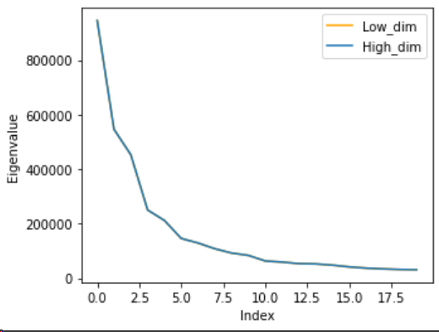
Figure 1: The values of 20 largest eigenvalues of original PCA (High-dim in figure) and low-dimensional PCA (Low-dim in figure) method. Later one is fully covered by another one.
Abstract

The ABSTRACT

Computationally Efficient Eigenfaces
We partitioned the face data into training and testing data with ratio 4:1 and implemented PCA and low-dimensional PCA methods. For the detail about how we wrote the code, refer to the source code. The reconstruction error and computation time of each method are illustrated in Figure 2.

Eigenvectors and eigenvalues
As we can see in the Figure 1, eigenvalues of two methods are exactly same. Also, we found that eigenvectors of two methods have same value when those from low-dimesion computation is multiplicatied with matrix A. They got opposite sign so that while running the algorithm, there is no difference between two methods. We can find it at the output of our source code.

Pros and Cons of each method
As illustrated in Figure 2, reconstruction error of both methods do not have significant difference. But in terms of computation time, low-dimensional PCA method shows notable performance. Its average computation time is about 60 times faster than original PCA method. Since both methods compute same result as we have shown in 1.1, we prefer to use low-dimensional PCA.
However, since low-dimensional PCA method computes smaller number of eigenvectors, in our case 416, than original PCA method, in our case 2576, it might result less accurate result. Since low-dimensional PCA method can compute all of influential eigenvectors, which mean eigenvectors with large eigenvalues, it can result in quite meaningful result. But since original PCA method can use more eigenvectors for reconstruction, it can result in more accurate result.

Varying number of PCA bases learnt
The result of PCA method depends on the number of PCA bases. As we use more PCA bases, we can get more accurate result. As we can see in Figure 2, computation time also varies, but with small fluctuation. But reconstruction error decreases continuously as we use more PCA bases. It means that each PCA base contains the feature of train image and does its role on the performance. This also explains the advantage of original PCA method we mentioned in 1.2.

Incremental PCA
We partitioned the face data as in 1 and also divided train data to 4 parts with same number of each face label. Here, we ignored all other computations and just focused on eigen-decomposition. For further details about the implementation, please refer to the source code.

Batch PCA
For batch PCA, we used low-dimensional PCA method that we implemented in 1. We used 100 PCA bases since according to the experiment we did in 1.3, the slope of reconstruction error seems to be gentle when number of PCA bases become larger than 100. The training time was about 0.295 sec and reconstruction error was about 9.29e12. We computed face recognition accuracy with NN classifier and got 0.40.

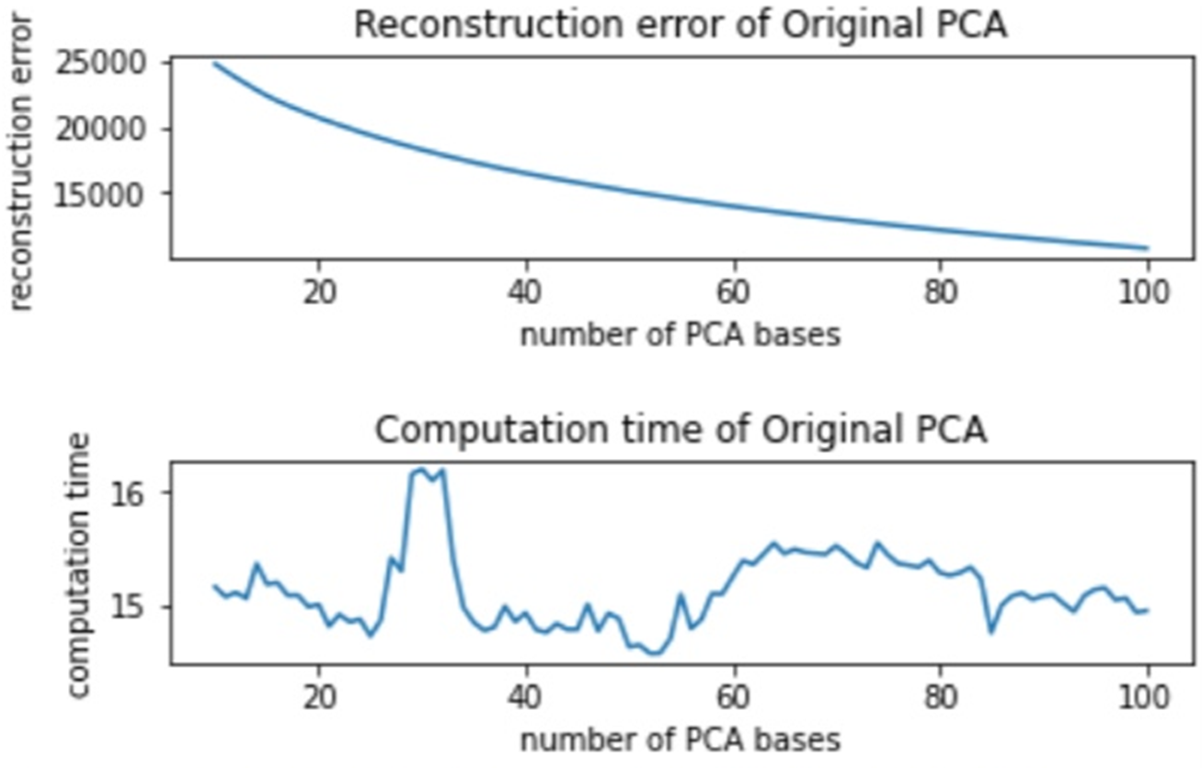
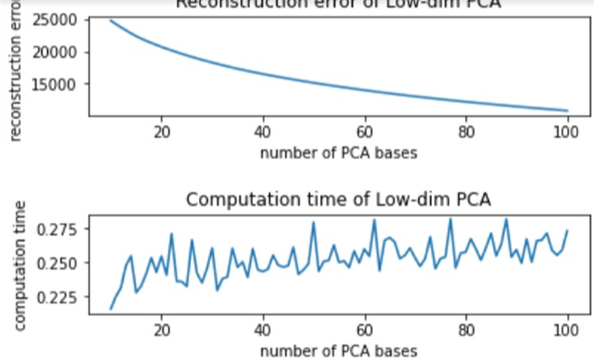
PCA trained only by the first train subset
(a) (b)
Figure 2: Reconstruction error and computation time of (a) original PCA with average computation time 15.14 sec and (b) low-dimensional PCA method with average computation time 0.25 sec.
We trained PCA only by the first train subset. We used original PCA method at this time, for merging process in incremental PCA method. We used 25 PCA bases since we wanted the number of PCA bases in incremental PCA method to be 100 after merging process. Here, it took 14.077 sec, which is similar to the computation time of original method that we mentioned in 1. The reconstruction error is about 8.34e3. In our opinion, it has much smaller reconstruction error because of smaller number of train data and our function that calculate reconstruction error does not consider the size of train data. Face recognition accuracy with NN classifier was about 0.029. It is very small compared to batch PCA. It is because we train the model with 4 times smaller train data. We can know that size of train dataset has huge effect on recognition accuracy.

Incremental PCA
We implemented incremental PCA method as described in lecture note. Its computation time for merging 4 models is 0.017 sec, which is much shorter than computation time of original PCA method, even smaller than that of low-dimensional PCA method. It shows that when we have models for partitioned train data, we can easily get the model that cam be applied to whole train data with very small effort. Reconstruction error of this method is 1.99e7, which is way smaller than batch PCA method. It shows that even with smaller computation, we can get reasonable result using incremental PCA. However, its recognition accuracy is about 0.106, which is more than 4 times larger than 2.2, but almost 4 times smaller than batch PCA. We can know that with incremental PCA method, we can get the result very fast, but accuracy may be not meaningful.

PCA-LDA for Face Recognition
Since dimension of the data is way bigger than cardinality, with-in scatter matrix is singular in our case. To deal with it, we implemented PCA-LDA method to find optimal solution by reducing the dimensionality of given data set. Here, we used low-dimensional PCA method that we implemented in 1 and same data set used in 1. For further details about the implementation, please refer to the source code.

Since rank of rach scatter matrices are limited, 416 - 52 = 364 for , 52 - 1 = 51 for , we varies the number of hyper-parameter (M_pca, M_lda) within this range. We optimized M_pca value from 51 to 364, The reason why the lowest number is set to 51 is that if it is set to less than 51, there is a restriction when determining M_lda. As we can see in Figure 3, when M_pca is 160, It shows most accurate result. The reason why the accuracy increases up to 160 is probably (노이즈 제거...라는 식으로 써도 될까?!). Conversely, the reason decreasing section is probably because PCA method loses too much information that distinguishes classes. As M_pca value grows above 160, LDA takes less part when calculating optimal solution, which is not desirable since PCA method doesn't take into account class labels. By the way, there's another notable point that regardless of the M_pca, it performs much better than PCA method. Therefore we can conclude that LDA method is better than PCA method when it comes to supervised learning.

As in PCA, number of LDA bases affects the result. Accuracy grows up along the number of LDA bases, with fluctuation in computation time. We can see that each bases have meaningful information, and does its role when it comes to accuracy.
The rank of and obtained in the process of PCA-LDA with 160 M_pca value and 51 M_lda is 364 and 51 respectively. This number completely fits the definition of thier ranks.

Fifure 4 shows confusion matrix of same case. Among 104 entries, only 7 is out of our expectation. One interesting point is class 14 and 34 has symmetric error which means their data probably have similar facial informations.
Time is also remarkable. Low-dimensional PCA method took 0.25 sec as in Figure 2, however, PCA-LDA method took 3.19 sec as in Fifure 3 even though it uses Low-dimensional PCA method for its first step. Since it needs to calculate , and eigenvectors, so that it takes almost 13 times longer.

(메모리 부분...도대체 뭘 써야하지...?)

PCA-LDA Ensemble
There are 2 ways of enabling ensemble, here we concentrate on random sampling in feature space, not bagging. Before we do radomization, we projected image data with 415 PCA bases to avoid overfitting. For the details of implementation, please refer to the source code.

Randomization in feature space
As we saw in Figure 3, 160 for M_pca was the best choice in PCA step. Referring to this, we set M_pca, sum of M0 and M1, to be greater than 100 and less than 200 to get meaningful result.

Number of base models
Content.

Error
Error of committee machine vs average error of individual models

Fusion rules
Majority voting / sum

Recognition accuracy and Confusion matrix
Content.

K-means codebook
Vocabulary size
Bag-of-words histograms of example training/testing images
Vector quantization process (briefly explain)
---------------------------------------------------------

RF classifier
Varying parameters - # of trees / depth of trees / degree of randomness parameter / type of weak-learner(axis-aligned / two-pixel test)

Recognition acc / confusion matrix
Example success / failure
Time-efficiency of training/testing
Impact of vocab size on classification acc

RF codebook
Content.

References
- https://github.com/sw-programmer/Coursework1
- [reference for RF classifier]
- [lecture slide]

